TSANet Connect

Salesforce Install Guide

# Install / Uninstall Package.

**Note:** Please ensure an existing Beta package is not installed, as it will give an error. You need to uninstall the preview package and install the new one. Before uninstalling the old package, you must remove the LWC from the Case page.

# Install the Package

Obtain the link to the latest version of the package at the TSANet Github Connect 2 Release site: <https://github.com/tsanetgit/SFDC>

Copy the link from the Github readme into your browser and login to your Salesforce to start the process.

Select Install for All Users and checkbox below -> Click Install -> Select checkbox: Yes, grant access to these third-party websites -> Click Continue.

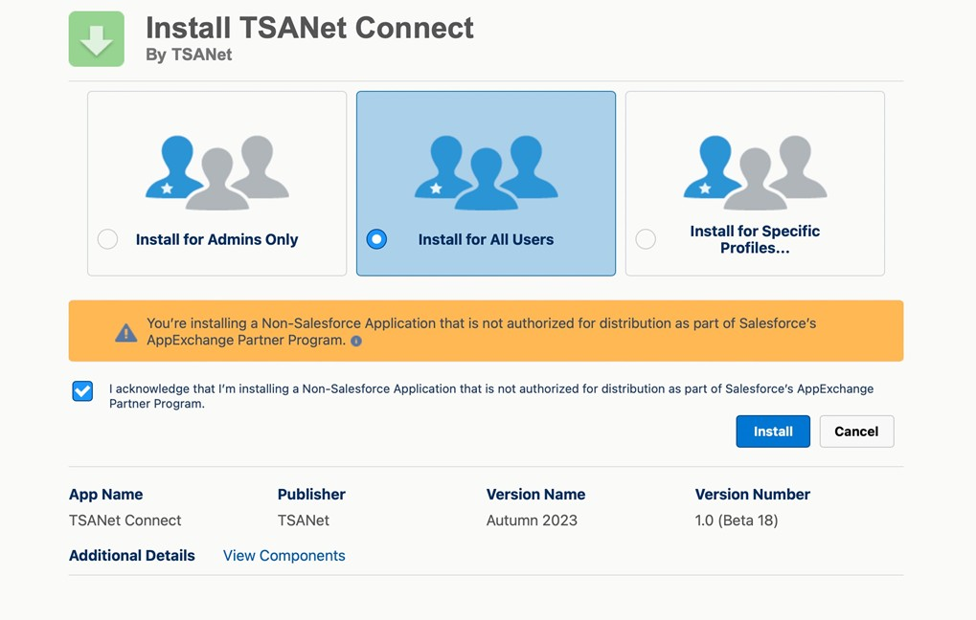

Screen below will show the version you are installing.

# Configuration with TSANet Credentials

The packages uses Basic Authentication to communicate with TSANet Connect. An API user is created on the Member account and used in the process below.

# Permission Sets for the package

Create a new record with the provided credentials, set the environment, and mark this connection as the primary live one. **Only the ‘Is Primary’ credential is used** and must be selected.

## Environments: TSAnet has the following environments

* Developer: Only used by developers who are making changes to the package
* Beta: Used by Members to test before moving to production
* Prod: User by Members in Production

# Setup TSANet Cases List:

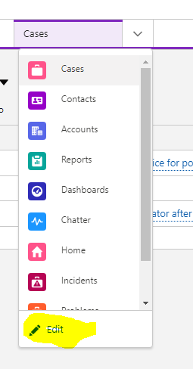

>Go to the Service Console.

>Select Edit for the List dropdown:

>Select Add More Items

>Add TSANet Cases list

>Select Add More Items

>Add TSANet Cases list

# Setup TSANetApplication component:

Go to the Case record page. Click Gear Icon, then Edit Page button. Find the

TSANetApplication component and drag and drop it to the appropriate place -> Click Save.

Note: Other options for Case page customizations are available using flows and actions. See the Case Customization section at the end of this document for details.

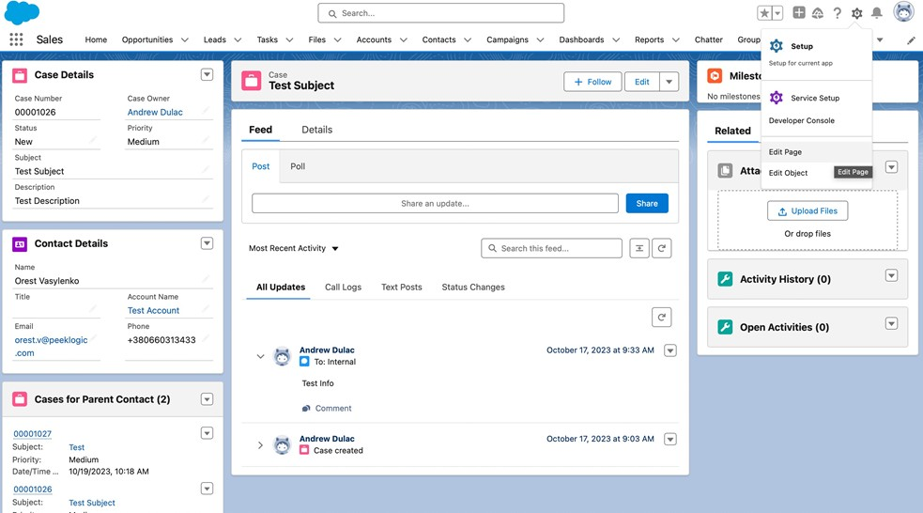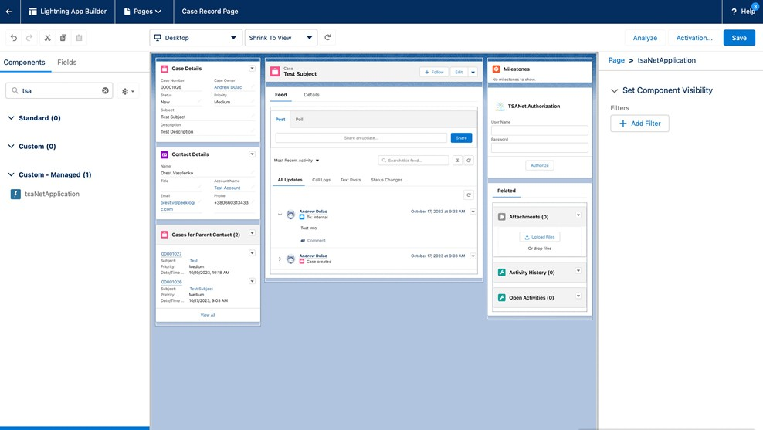

Click the Activate button -> Select APP DEFAULT tab -> Click Assign as App Default -> Choose your app -> Click Next button and assign desktop and phone version -> Click Next and Save button.

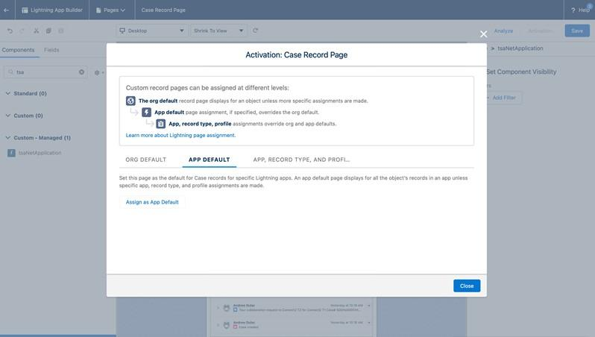

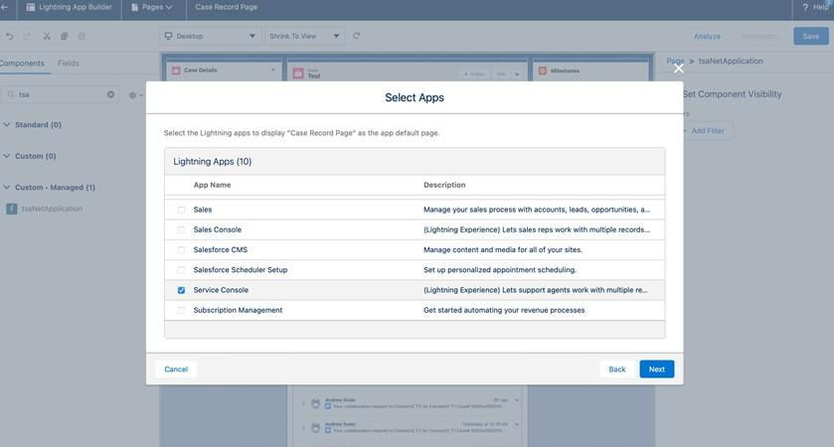

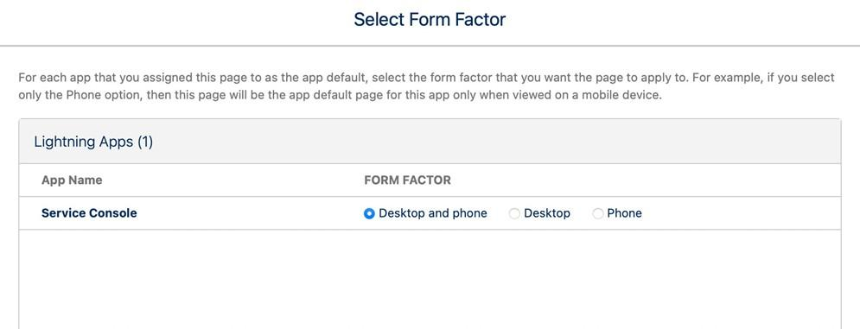

**Add the TSANet Case-related list view to the Case page layout.**

Go to Setup -> Object Manager -> Case -> Page layout -> Select your page layout -> Scroll to related list section -> Drag n drop TSANetCase related list to layout -> Save.

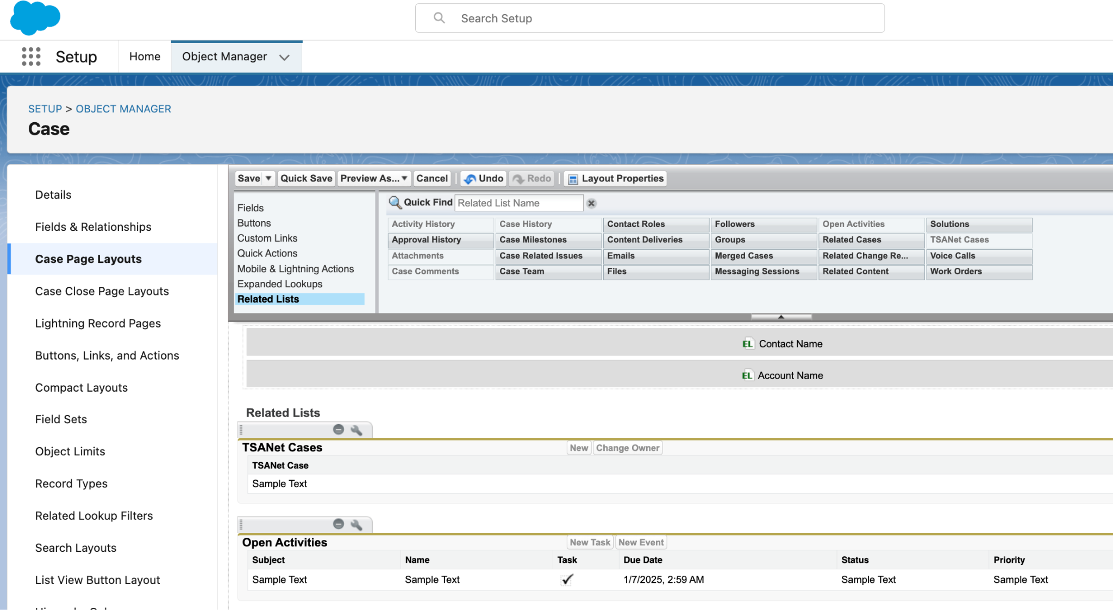

# Assign Users to TSANet Connect Permission Set

Go to Setup -> Permission Sets -> Search and Select TSANet Connect Permissions (Admin) or TSANet Connect Permissions (Employee) -> Click Manage Assignments button -> Click Add Assignment button -> Select Users -> Click Next button -> Select an Expiration Option For Assigned Users and click Assign button -> Done.

# Package Details and Configuration Options

## Objects

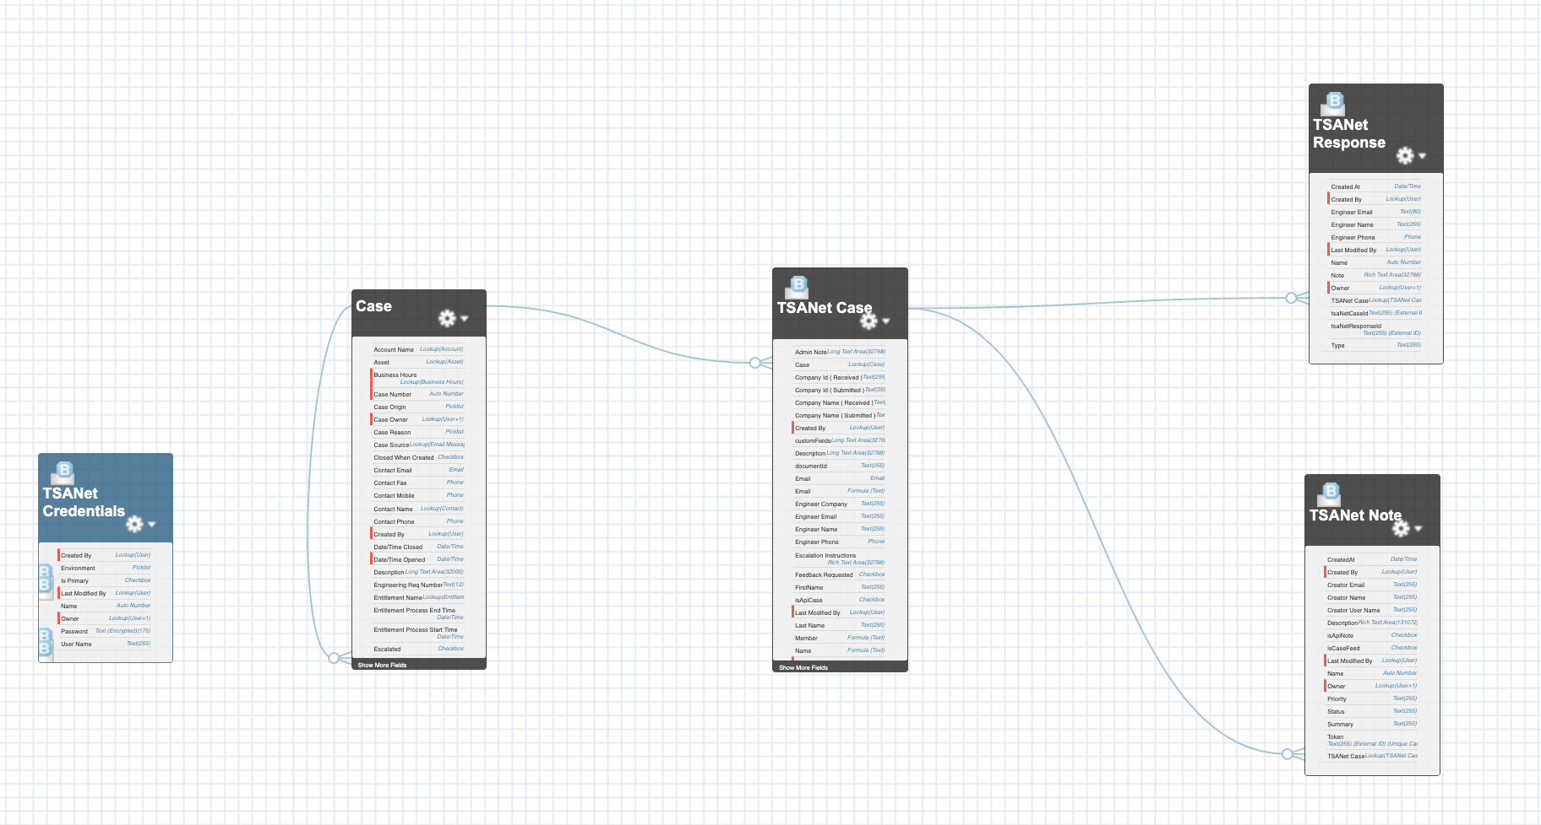  
**TSANet Case** - A collaboration case within the TSANet framework that serves as the primary record for tracking collaboration between member organizations during a support issue.

**Key attributes may include:**

* TSANet CaseID
* Case (lookup field)
* Status [ACCEPTED, OPEN, INFORMATION, CLOSED, REJECTED]
* Type [INBOUND, OUTBOUND]
* Priority [LOW, MEDIUM, HIGH]
* Priority Note
* Summary
* Description
* Request Date
* Response SLA (Datetime)
* Token (ExternalID)

**Member Information:**

* Company Name (Submitted)
* Name
* Email
* Phone
* Company Name (Received)
* Engineer Name
* Engineer Email
* Engineer Phone

**Other Information** (custom fields)

**TSANet Note** – the object is used for logging and managing communications or updates related to a TSANet Case. It allows members to document important information about the case in real-time

**Key attributes include:**

* TSANet Case (lookup)
* Summary
* Description
* Creator Name
* Status
* Priority [LOW, MEDIUM, HIGH]
* Created At
* Token (ExternalID)

**TSANet Response** - object captures formal replies or actions taken with an inbound TSANet Case.

**Key attributes include:**

* TSANet Response ID (ExternalID)
* TSANet Case (lookup)
* Type
* Note
* Created At
* Engineer Email
* Engineer Phone

**TSANet Credentials** - object stores and manages secure access information within the TSANet framework. This object ensures member organizations have the necessary authentication details for collaborative support.

*\* you can have only one credential marked as primary.*

**Key attributes may include:**

* UserName
* Password
* Environment [DEVELOPER, BETA, PRODUCTION]
* isPrimary (mark as true)

## Flows

The TSANet managed package includes flows designed for flexible automation. These flows enable actions such as updating TSANet records, creating new TSANet Cases, accepting or rejecting requests, requesting more information, or adding new notes. Additionally, all these actions are available in flows under the TSANet section, allowing you to customize the logic to meet your needs.

*\* You can clone the existing flows in the managed package and customize them to suit your specific needs.*

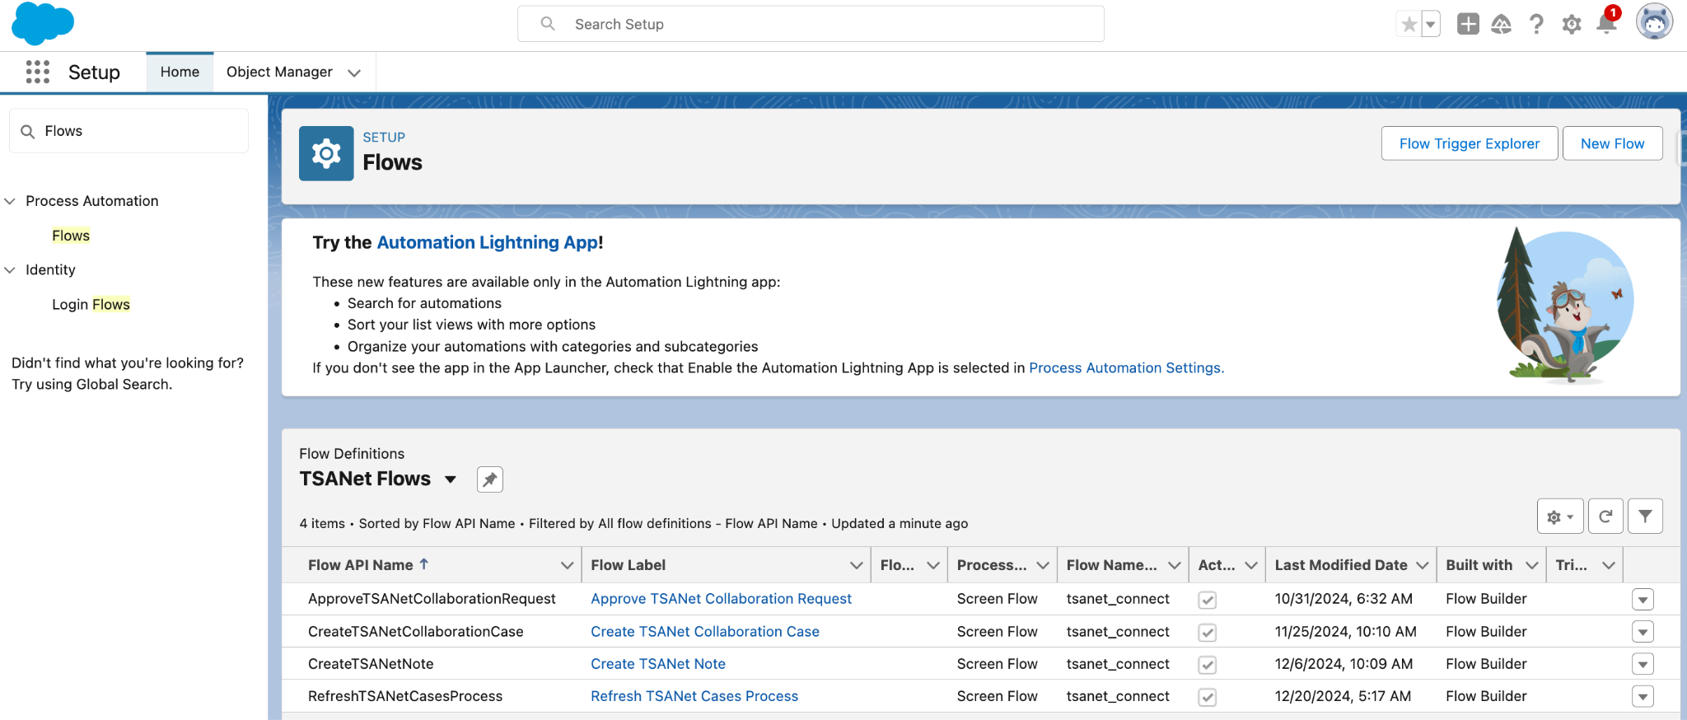

**Flow Templates**

* Create TSANet Collaboration Case
* Create TSANet Note
* Approve TSANet Collaboration Request
* Refresh TSANet Cases Process

**Invocable actions**

* Create TSANet Collaboration Case
* Approve TSANet Collaboration Request
* Get TSANet Companies
* Get Company Form
* Create TSANet Note

## Quick Actions

**Create New TSANet Case / Collaborate (TSANet)** - this actionallows you to create a new TSANet case. You can use a quick action (via LWC or Flow) or TSANet LWC component - **tsaNetApplication**).

Click **“New”** or **“Collaborate (TSANet)”**. Find the company you want to collaborate with -> Click **“Next”** -> Fill in all the required fields and click **“Submit”**

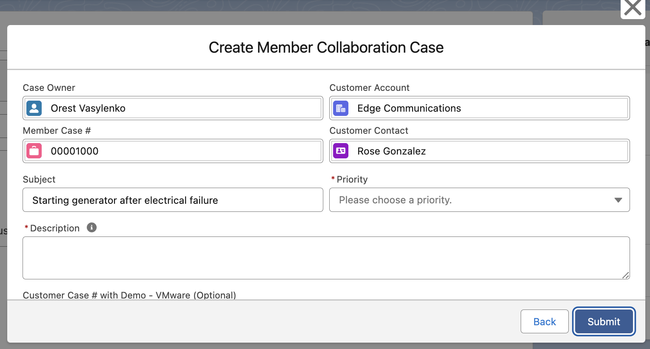

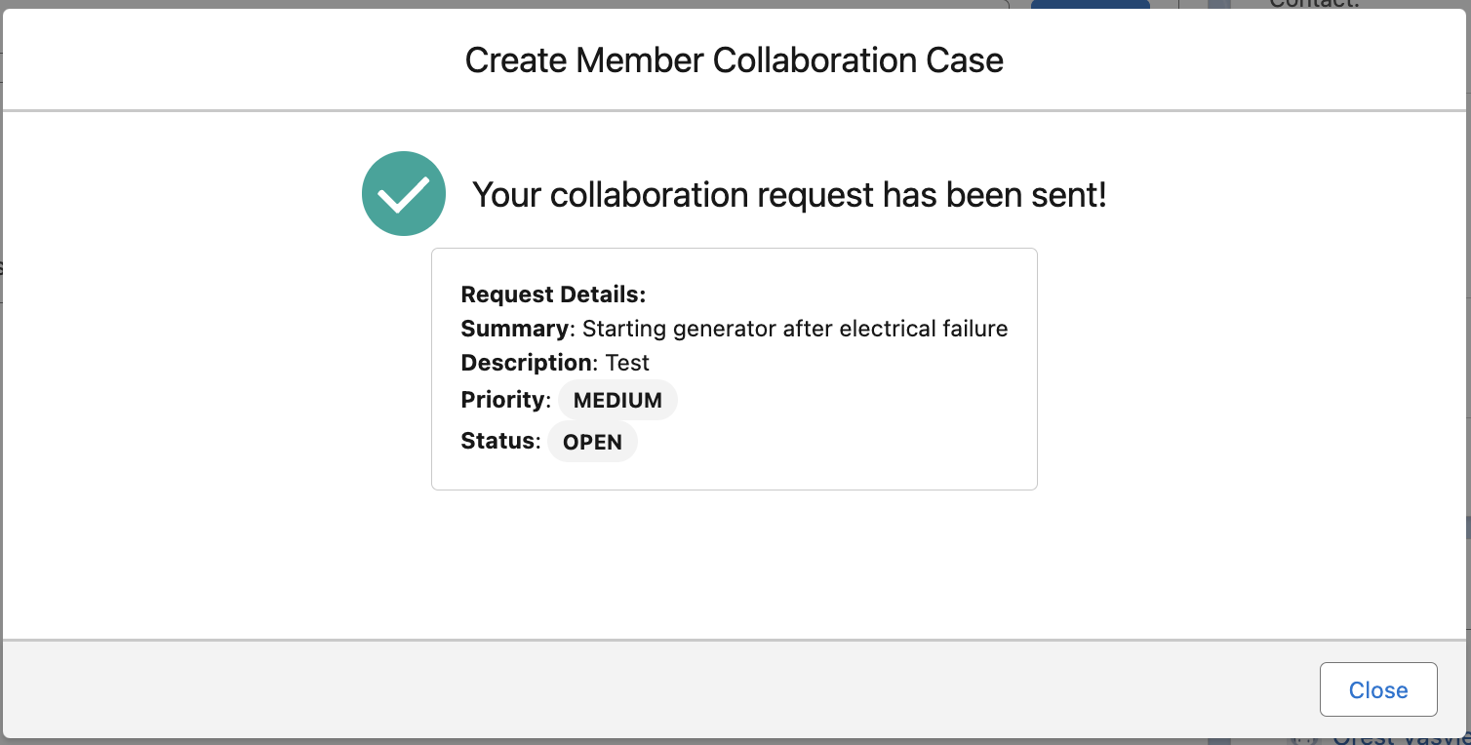

**Create New Note** *- this action allows users to add supplemental information or comments to a TSANet Case. This action is useful for documenting key updates, observations, or decisions related to the case.*

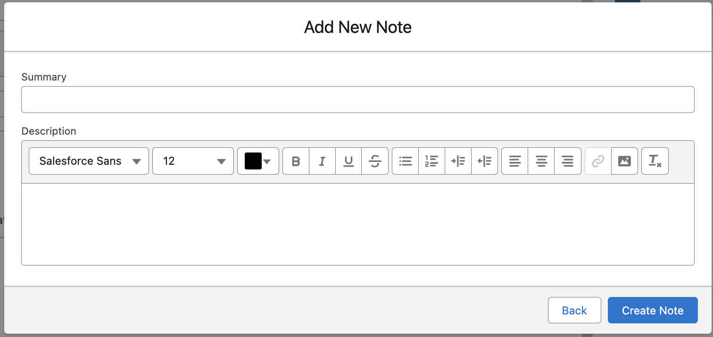

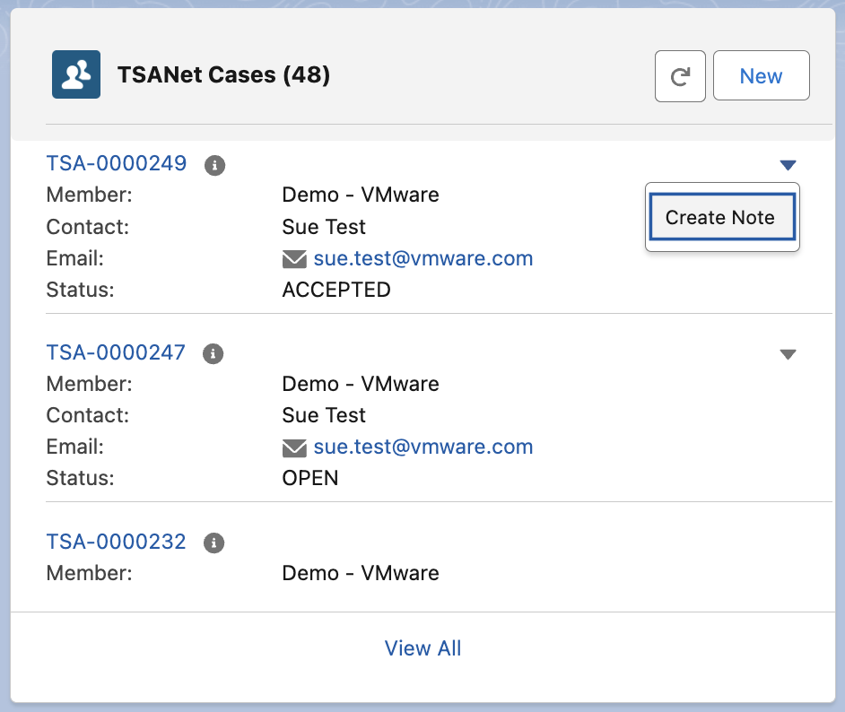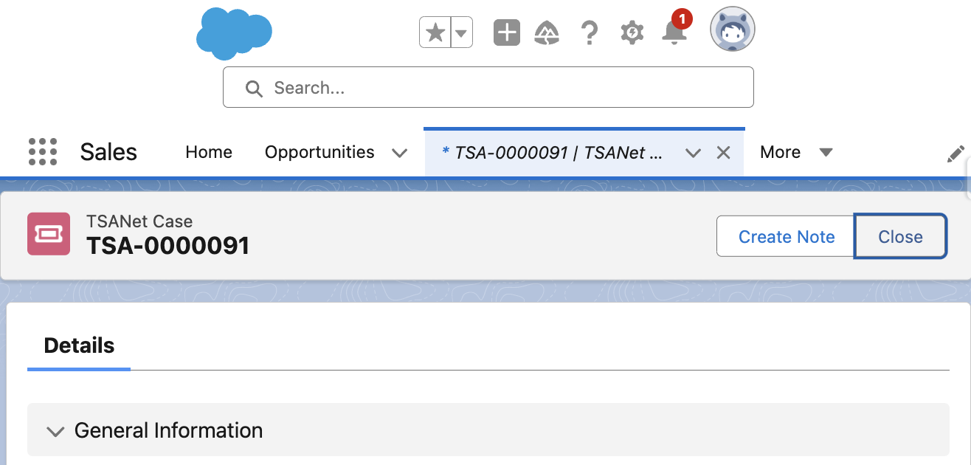

*Create note is also available on LWC and TSANet Case*

**Refresh TSANet Cases (Page Layout & List View)**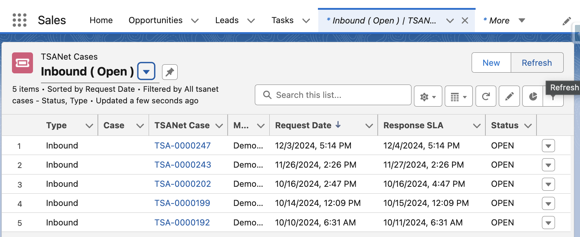

*Case Record Page - you can add these actions to your Case page layout.*

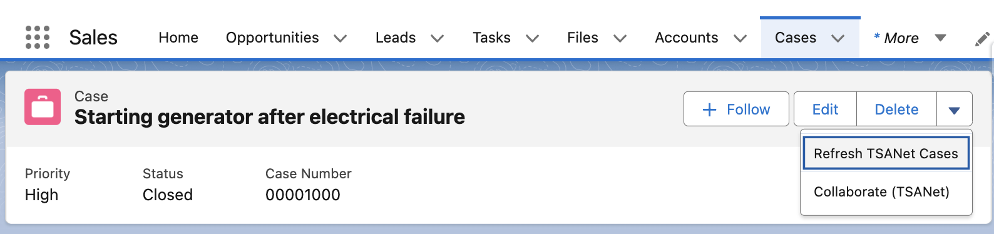

**Approve** - When a TSANet Case is created to collaborate with another company, approval from the other party is required to ensure mutual agreement for the collaboration.

You can accept only inbound TSANet Cases

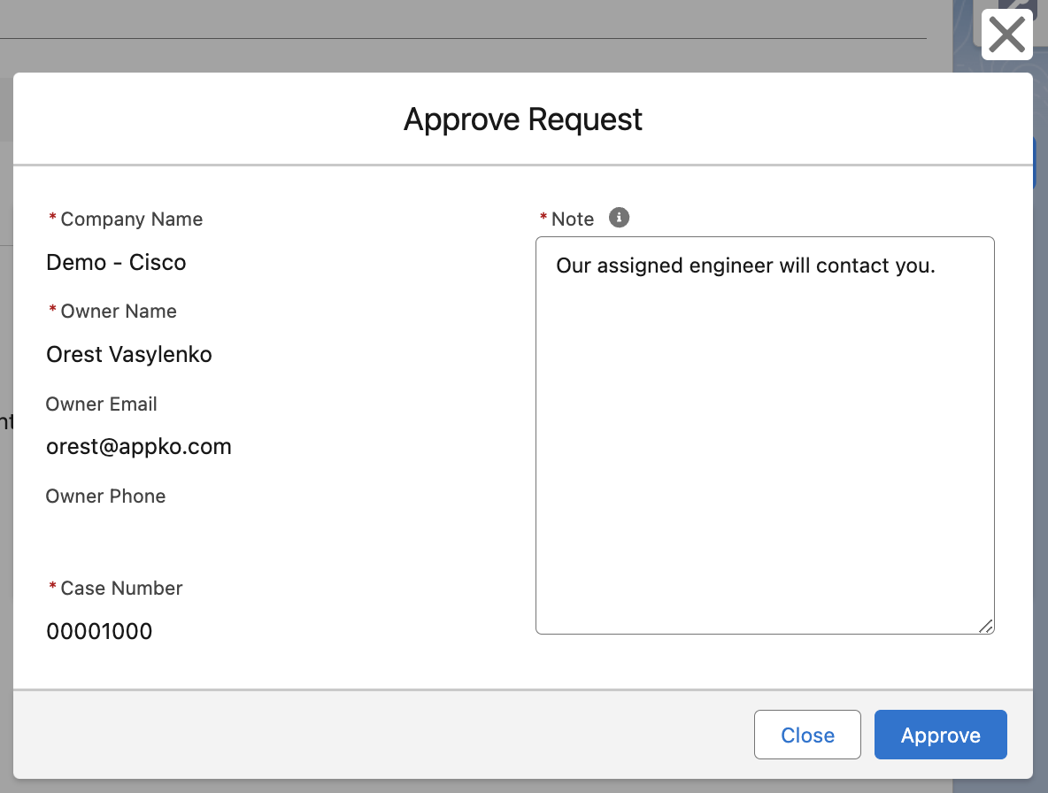

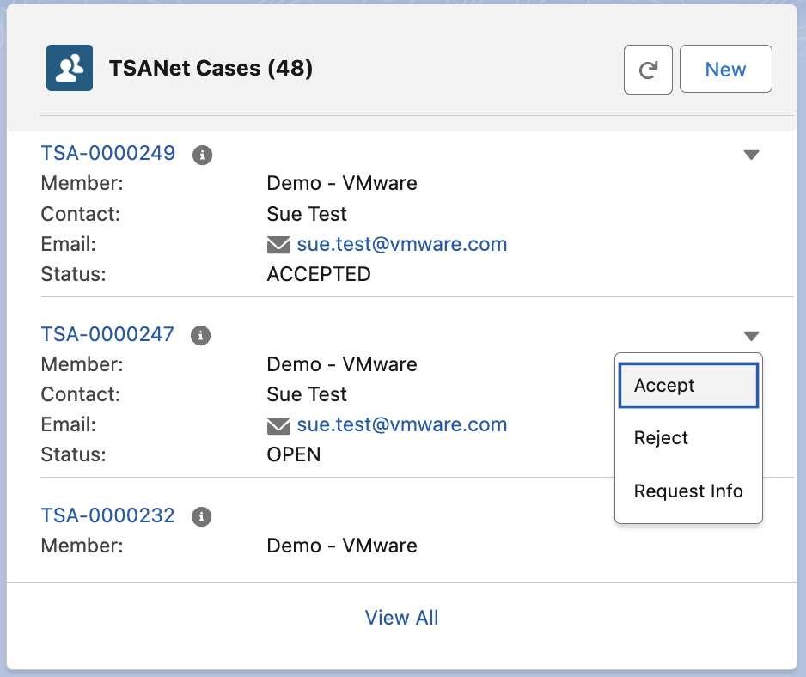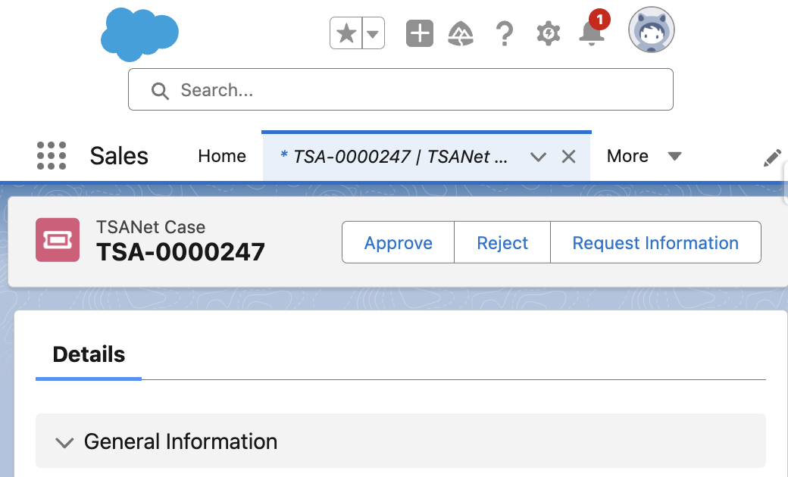

**Request Additional Information** - this action allows a collaborating company to ask for more details before approving a TSANet Case. This ensures that all necessary information is available to proceed effectively.

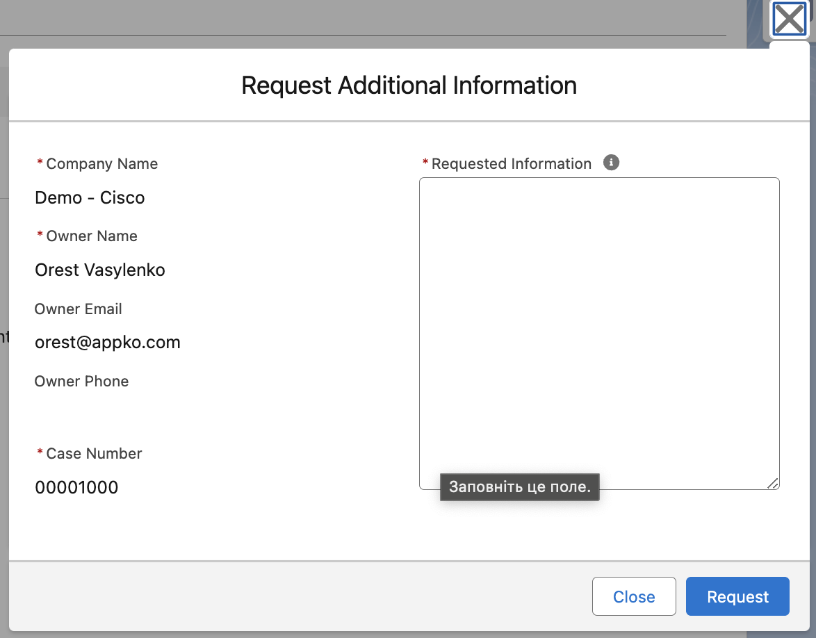

**Send Requested Information: This** action allows the initiating company to provide additional details or respond to a request for clarification on a TSANet Case. It ensures the receiving company has all the necessary information to proceed with the approval.

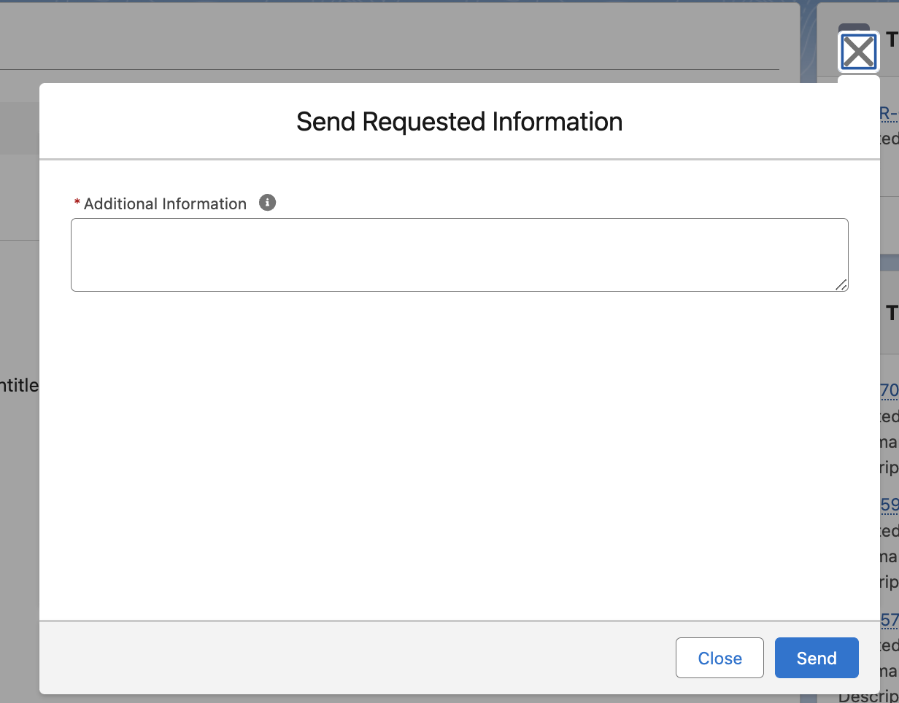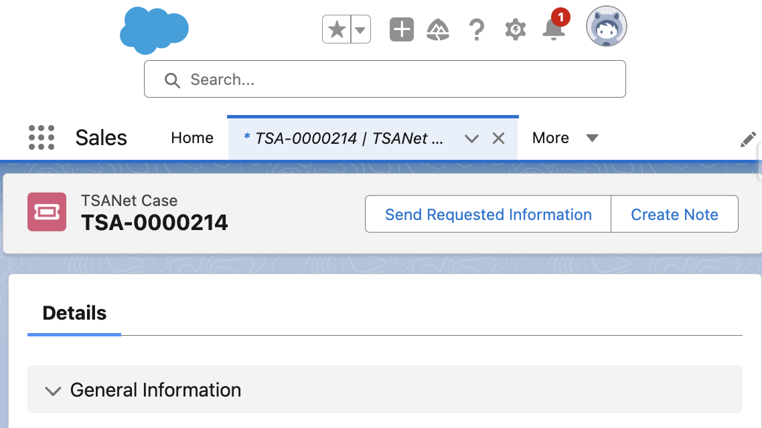

**Reject -** This action is used when the receiving company decides not to proceed with the submitted TSANet Case. It ensures clarity and concludes the request without moving forward with collaboration.

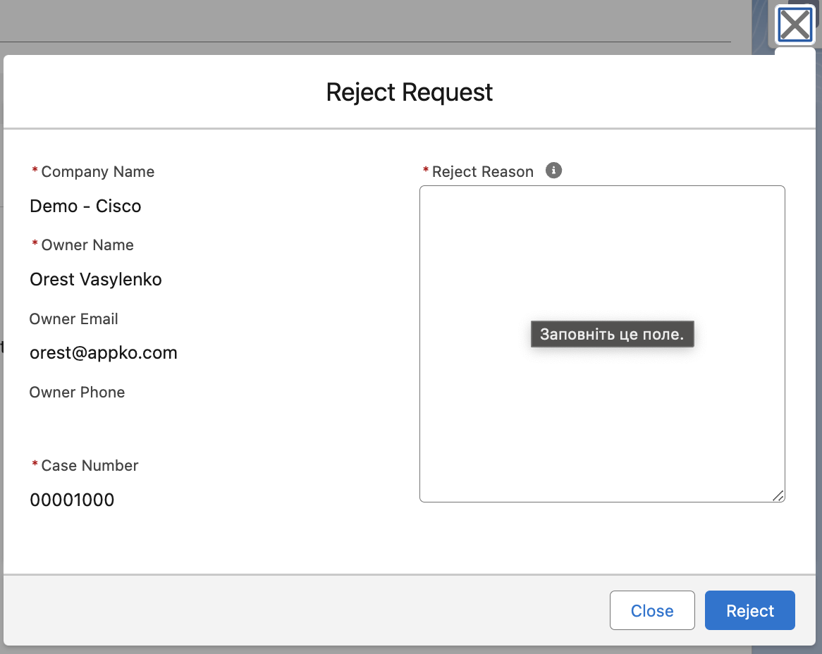

**Close -** this action is used to formally close a TSANet Case. The TSANet system will auto-close TSANet cases that have not had any activity for 30 days.



# Visual Studio setup

This section is for developers who work on code modifications to the package.

**Step 1: Install Visual Studio Code**

Download and install Visual Studio from the oﬃcial Microsoft website.

Link: <https://visualstudio.microsoft.com/ru/free-developer-offers/>

**Step 2: Install Salesforce CLI (command-line interface)**

If you haven't already, download and install CLI

Link: https://developer.salesforce.com/tools/salesforcecli

**Step 3: Install Salesforce Extension Pack**

1. Open Visual Studio.

2. Go to the Extensions menu, then select "Manage Extensions."

3. In the Extensions window, search for "Salesforce Extension Pack."

4. Click on the "Download" button and then click "Install" to install the extension pack.

5. Restart Visual Studio to activate the extension pack.

**Step 4: Create or Open a Salesforce Project**

1. In Visual Studio, go to the File menu, then select "View" > "Command

Palette…">”SFDX: Create Project with Manifest”>Enter Project Name

2. Specify location, then click "Create."

3. If you already have a Salesforce project, you can open it by selecting "Open

Folder" from the File menu and navigating to the project directory.

**Step 5: Connect Visual Studio to Your Salesforce Org**

1. Go to the View menu, then select "Command Palette."

2. In the Command Palette, type "SFDX: Authorize an Org" and press Enter.

3. Choose the appropriate option to log in to your Salesforce org

4. Follow the prompts to complete the authentication process.

**Step 6: Retrieve Source From ORG**

1. After creating or opening the project, locate the Manifest folder in the Solution

Explorer panel on the left side of the Visual Studio window.

2. The Manifest folder contains metadata ﬁles (e.g., package.xml) that deﬁne the components to retrieve from the Salesforce org.

3. right-click on package.xml ﬁle and choose "Retrieve Source with Manifest from Org."

**Step 7: Deploy Source To ORG**

1. right-click on package.xml ﬁle and choose "Deploy Source with

Manifest To Org."

